**PostgreSQL + Info-Gathering:**

**CMF – PostgreSQL Info-Gathering Automation for Windows - User Guide**

**For Script:**

**CMF_PostgreSQL_Windows_Info_gathering.ps1**



**Document Summary**

|  |  |
| --- | --- |
| **Document Item** | **Current Value** |
| Document Title | CMF – PostgreSQL Info-Gathering Automation for Windows - User Guide |
| Program | CSU Migration Factory |
| Date Last Modified | 18-Dec-2023 |
| Date Last Reviewed | 18-Dec-2023 |
| Current Document Known Issue | N/A |
| Status | Initial |
| Document Description | This document provides the procedure/steps to execute the Automation script which gathers the PostgreSQL Server details. |

**Revision History**

This section represents the change history of the document. Revisions of the document must be tracked by identifying a new version number, the date it was modified, the person making the change, and the reason for the change.

|  |  |  |  |  |
| --- | --- | --- | --- | --- |
| Date | Version | Change Description | Author | Reviewer |
| 15-Oct-2023 | 1.0 | Initial Version | Chethan, Mukesh Lekshmy, Arun | Rackimuthu Kandaswamy |
| 18-Oct-2023 | 1.1 | Added SSL Mode | Chethan, Mukesh Lekshmy, Arun | Rackimuthu Kandaswamy, Sharad Khadtare |

Table of Contents

1. Executive Summary 4

1.1 Objective 4

2 Prerequisites for PostgreSQL Server Info gathering - Execution 4

2.1 Non-Mission-Critical system 4

2.2 Operating System Requirements 4

2.3 Software requirements 4

2.4 Input Excel File 5

2.5 Storage Space & Folder read write permission 6

2.6 Internet access 6

2.7 Without Internet access to the URLs below 6

2.8 PowerShell Version & Execution policy 6

2.9 Connectivity 7

3 Copying Script 7

3.1 Folder Name 7

3.2 Script and Input file 8

4 Executing the Script 10

4.1 PostgreSQL Info Gathering execution 10

4.1.1 Open windows Command prompt as **Administrator** 10

4.2 CMF_PostgreSQL_Windows_Info_gathering – Script execution 11

4.2.1 Export Info-Gathering details and generating Excel Output files 13

4.3 Automation Script Transcript Log 14

# Executive Summary

## Objective

This document provides the procedure/steps to execute the Automation script (CMF_PostgreSQL_Windows_Info_gathering.ps1) which gathers the PostgreSQL instance details.

Note: The values present in the Screenshots are demo values. Please change the values as Appropriate.

# Prerequisites for PostgreSQL Server Info gathering - Execution

## Non-Mission-Critical system

* **Don't install and run the Automation scripts on any mission-critical production server**

## Operating System Requirements

* Supported Operating System

Windows 10, Windows Server 2012, Windows Server 2012 R2 and above

## Software requirements

* PostgreSQL Client 11 and above
* Windows PowerShell 4.0 and above.

## Input Excel File

**Important Notes:**

* PostgreSQL Client is required to establish Connectivity to PostgreSQL Servers.
* This script is based on the CSV file named   
  ‘**CMF-PostgreSQL_Server_Input_file.csv**’.
* **Column Name must be kept as shown below, change in names will result in errors**
* **Values in the column must be correct, incorrect values will also result in errors**
* **Tenant and Subscription_ID columns are Optional.**

1. **Columns for Input File: CMF-PostgreSQL_Server_Input_file.csv**

|  |  |
| --- | --- |
| **Column Name** | **Note** |
| **Host_Name** | Provide the Host Name (Example : localhost) |
| **Port** | Provide the Port Number ( Example : 5432) |
| **VCore** | Provide the Number of VCore (Optional) |
| **Auth_Type** | Provide the Authentication Type(Optional) |
| **User_ID** | Provide the User_Id |
| **Password** | Provide the Password |
| **DB_Name** | Provide the Database Name (Example : postgres ) |
| **Tenant** | Provide the Tenant Id. (Optional) |
| **Subscription_ID** | Provide the Subscription Id. (Optional) |
| **Approval_Status** | Provide yes to fetch Information and No to cancel for the Host. |
| **SSL_Mode** | Provide SSL_Mode (Example : disable) |

|  |  |  |
| --- | --- | --- |
| **Seq.No** | **File** | **Note** |
| 1 |  | Sample: **CMF-PostgreSQL_Server_Input_file.csv** |

## Storage Space & Folder read write permission

* Windows user must have a privilege to create folder and write the assessment results to that folder
* Minimum disk free space required is 1GB

## Internet access

* Connectivity must be available from the client to the Target Systems and Internet.

## Without Internet access to the URLs below

**Note:** Follow the instructions below to download all the software manually to a server where internet connectivity is enabled. Once all the software is downloaded, move all of them to the server where CMF - PostgreSQL Server Info Gathering automation script will be executed and install all of them one by one.

## PowerShell Version & Execution policy

Execute the below commands from windows PowerShell as Administrator.

1. To find the PowerShell Version

* Get-Host

1. Set the PowerShell execution policy

* **Set-ExecutionPolicy Unrestricted -Scope CurrentUser**



## Connectivity

* Connectivity must exist between the SYSTEM which runs the PostgreSQL Info Gathering Automation script and PostgreSQL Server.

# Copying Script

## Folder Name info-gather ( unzip into folder files received )

* Login into a Non-Mission-Critical system (i.e.**NOT**on any production server) from where the PostgreSQL Automation is to be run
* Create a folder C:\Info-gather (you may choose any available drive)

## Script and Input file

Rename rename.txt rename.bat and run in info-gather folder

* Ensure the connectivity exists between the SYSTEM which runs the PostgreSQL Info Gathering Automation script and PostgreSQL Server.
* Once the input file is prepared Copy the file (**CMF-PostgreSQL_Server_Input_file.csv**) under the folder created in the previous step (C:\PostgreSQL)

# Executing the Script

## PostgreSQL Info Gathering execution

### Open windows Command prompt as **Administrator**

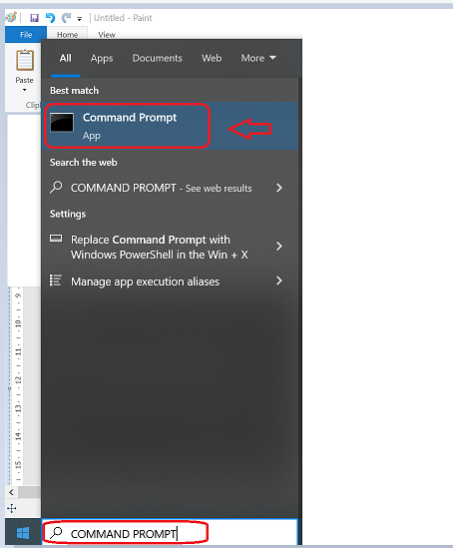

* Change the working directory/folder to the folder where you created/copied the script (CMF-PostgreSQL-Windows.ps1) in previous step
* Enter the following command at the windows command prompt.

**Powershell.exe -ExecutionPolicy RemoteSigned -File .\CMF-PostgreSQL-Windows.ps1**



## CMF_PostgreSQL_Windows_Info_gathering – Script execution

* To perform PostgreSQL server Information gathering, enter option ‘1’.

**Note :** After triggering the automation all the support folders( Logs, Output, Downloads etc. ) will be created automatically by the automation script, Psql path is validated and it will ask user to proceed with the execution of the script

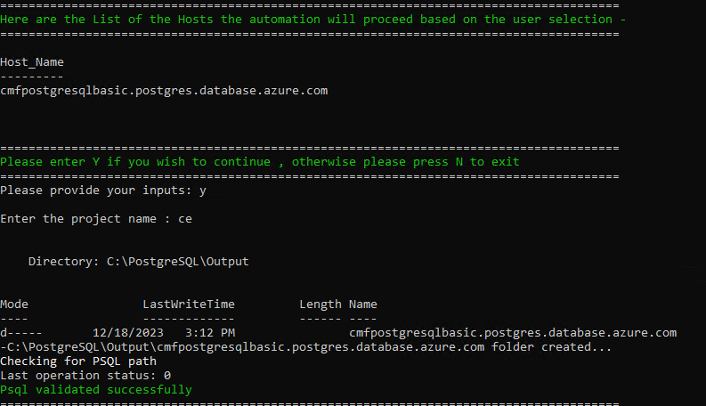

* The script then Validates the list of Hosts to proceed with execution. Continue by Entering “Y” and provide your Project Name. You’ll get below Final Status of the Script Execution.

Note: Ensure you add the location of psql.exe to your Path environment variables

* **To perform Detailed PostgreSQL server Information gathering, Re-run the script and enter option ‘2’**

CAUTION! :-

Please make sure this option is selected during OFF BUSINESS HOURS or LOW PEAK Period so as to avoid DATABASE PERFORMANCE

* The script then Validates the list of Hosts to proceed with execution as shown below.

* Next, enter “Y” and Project Name to proceed with Detailed PostgreSQL server Info-Gathering.

### Export Info-Gathering details and generating Excel Output files

Output is generated in Output Folder as below. **Please share the Compressed Zip File to CMF Team.**

## Automation Script Transcript Log

**Note:** For the Automation, transcript will be generated in text format as above

(.\Logs\ CMF_PostgreSQL_Windows_Info_Gathering_Transcript*.txt)